Product Mockup:

**Login Window:**

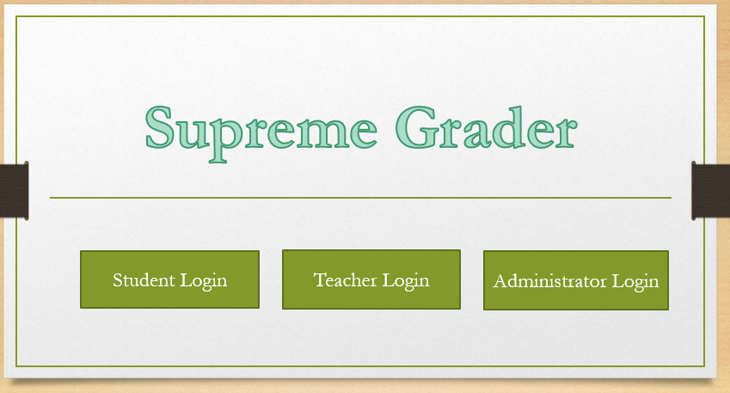

There are three login modes for the users and administrators. One for student, one for teacher, and another for administrator. You need to enter username and password to login.

**Main window for students and teachers:**

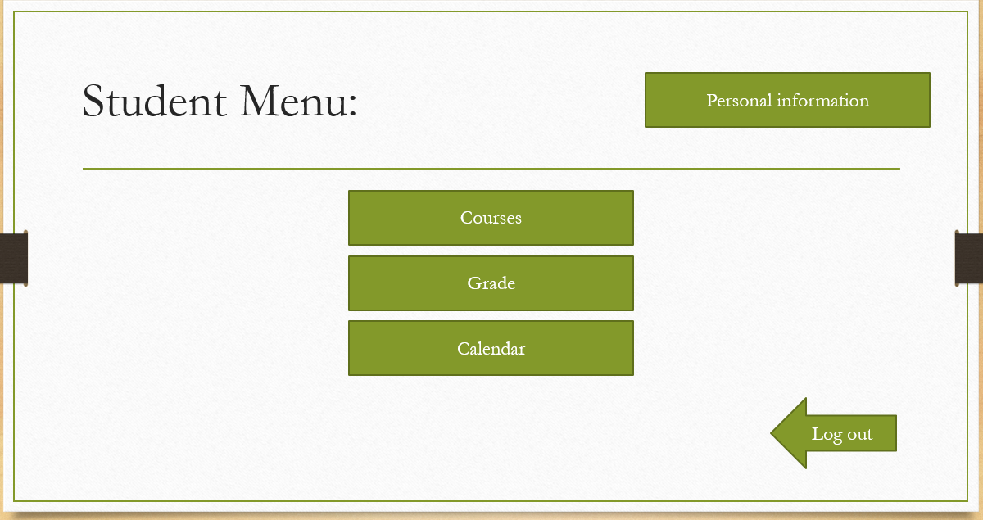

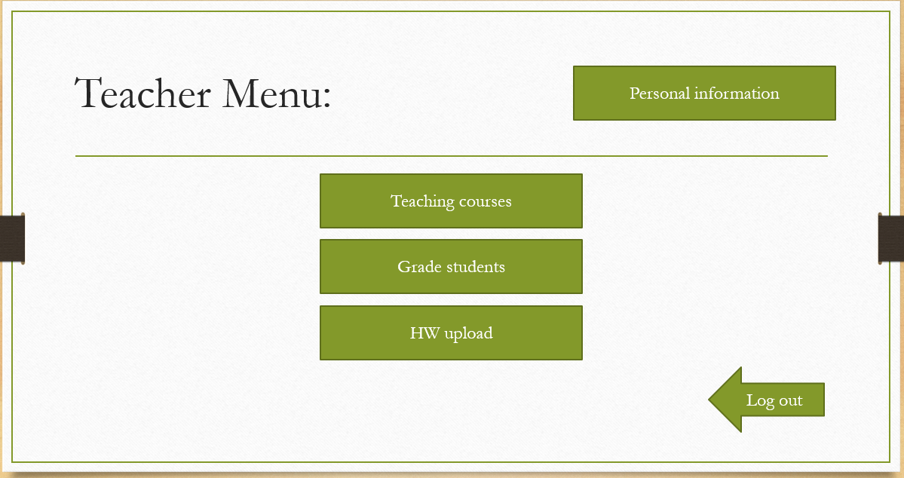

So here is the main window for students and teachers.

Student main window will have courses, grades, calendar. The courses include the course that student choose. The grades include every course grade and have the average grade of each course. And the calendar is for students to check all the events that will happen this day or month.

Teacher main window will have teaching courses, grade students and hw upload.

Both of the page have log out button and personal information.

**Student courses menu:**

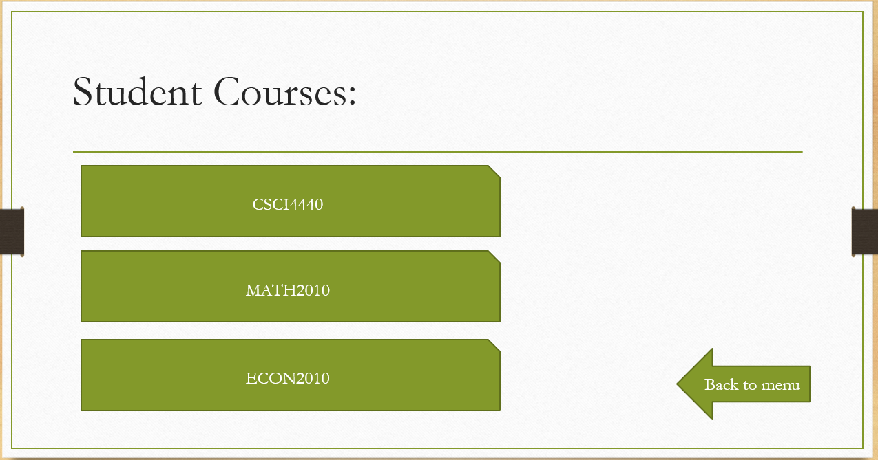

After we click on the student courses, we will have a list of course that student have. We will take Math 2010 for example.

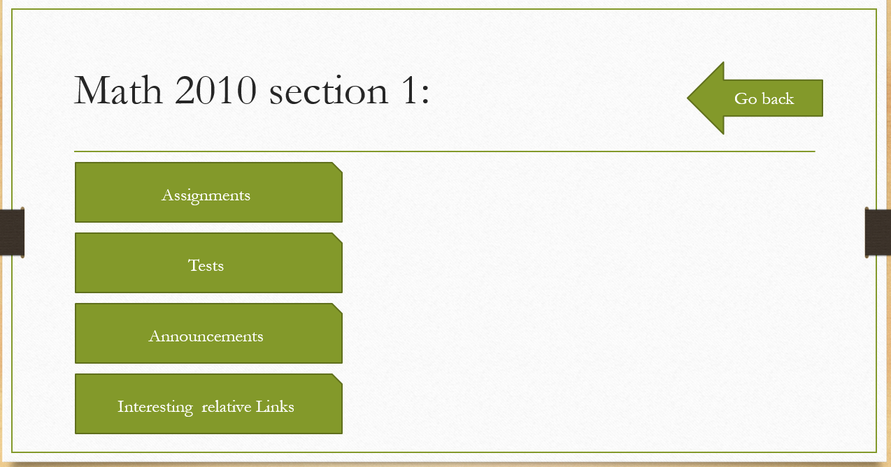

Here is the page after we click math 2010, we will see that there have Assignments, Tests, Announcements and Interesting relative links.

Announcements is for asking questions to teacher and get information from teacher. Interesting relative links will include a lot of links that helpful to Math 2010 class.

**Teacher course menu:**

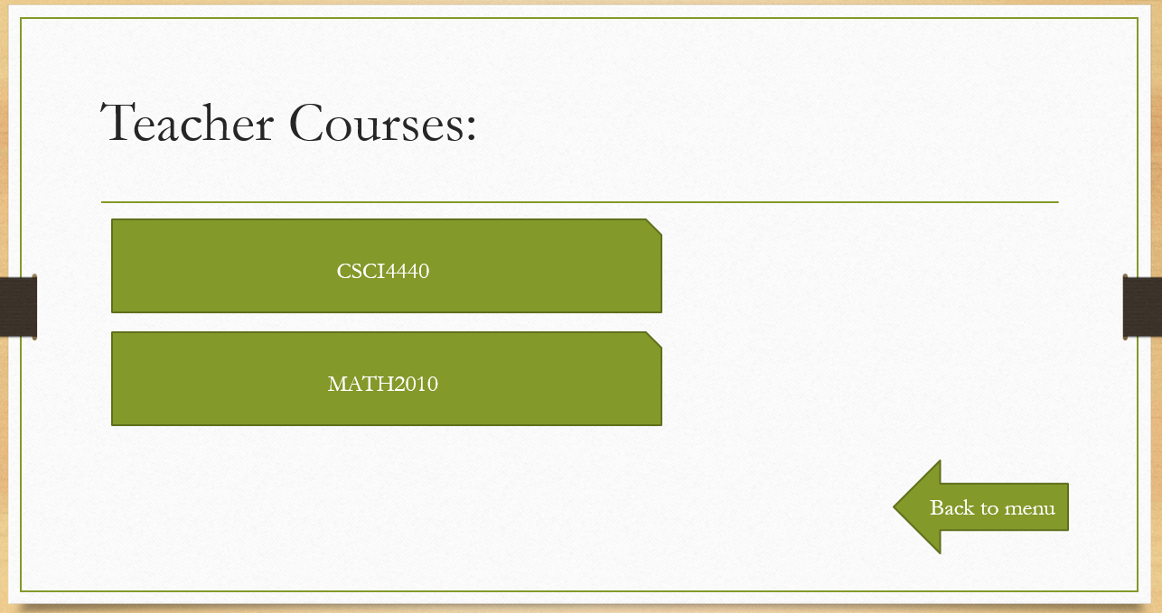

Teach course menu will also include class that teacher has.

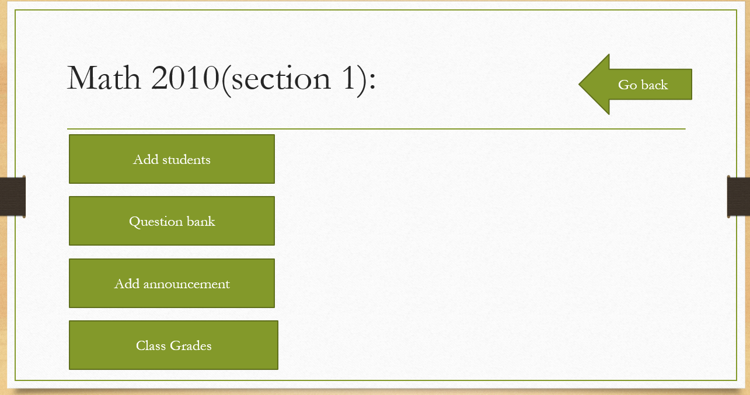

After we click on Math 2010 on teacher course menu, we can see that we have Add students, Question bank, Add announcement, and Class Grades.

Add students is for adding students to the courses. Question bank is for giving homeworks and tests to students. Add announcement is for communicate with students and provide notices. Class Grades include every student grade and the average.

**The test and hw page:**

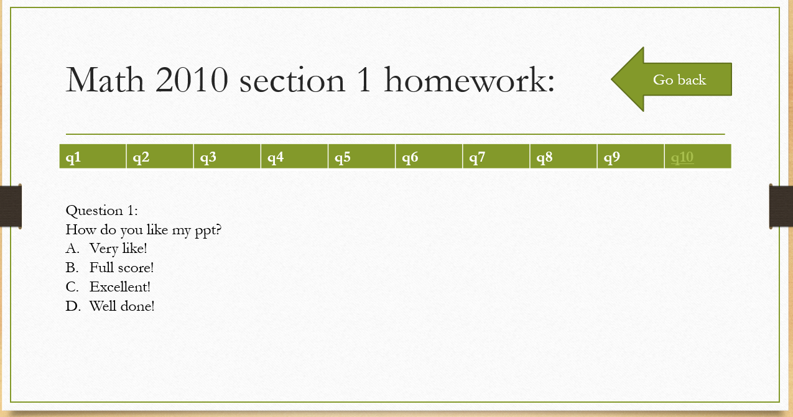

Here is the page for test and hw, we can change the number of question on the line of q1, q2,… line. For the hw, it has a go back option to go to the student course menu, but for the test page, it does not have the go back option. You can just submit when you are finished, you cannot leave the page at any time during the test.

**Interesting links page:**

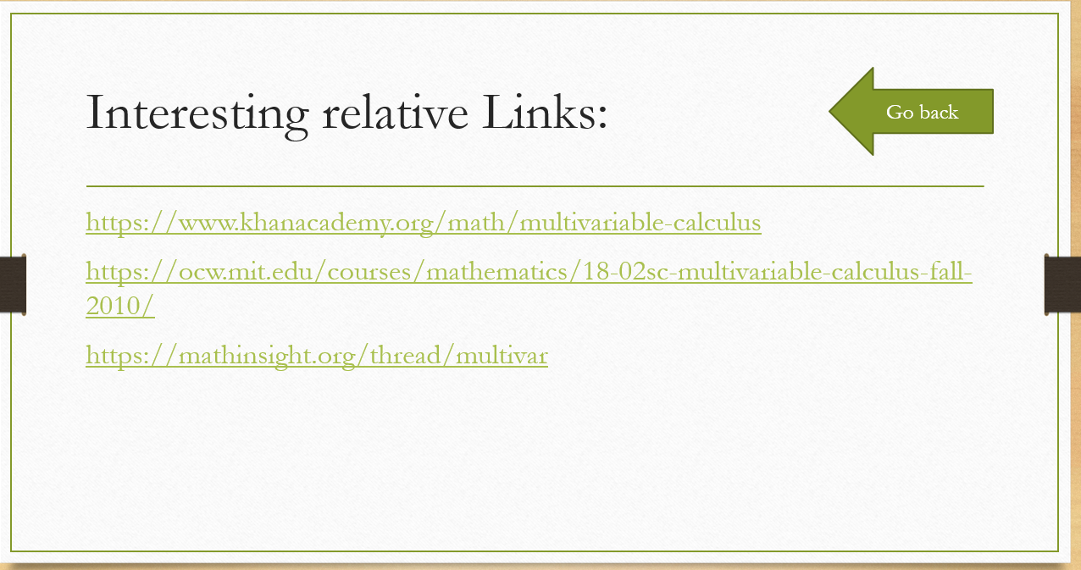

This function can make students learn the course easier. It will include a lot of useful staffs. Students can just click on the website and then learn the course.

**Teacher Add Announcement and Test Bank:**

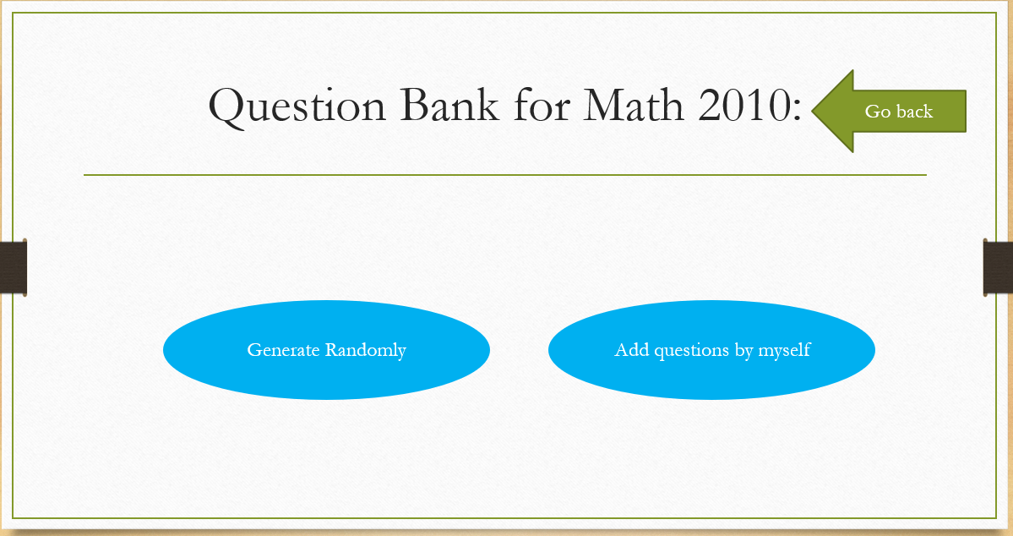

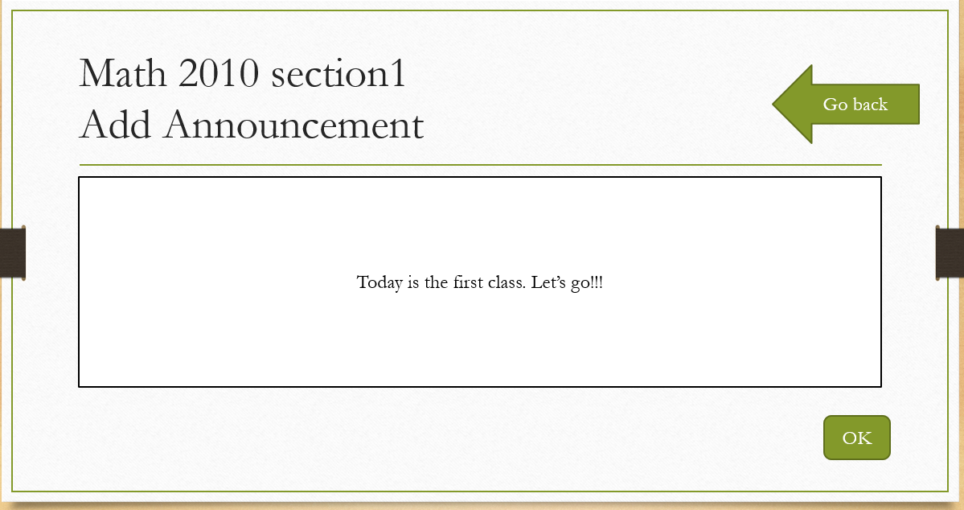

For the bank test page, it will include two button one is choose question from the question bank, another one is to upload question by themselves.

And for the add announcement page, it will include a text box that teachers can modify what they want to notice students. And after typing, click ok, it will be showed on both teachers announcement page and students announcement page.

**Other functions will be showed on the ppt:**

This is only a small part of our project. We have made a ppt so that you can click it and the ppt can show our project more vividly. Our basic conception of the buttons is from the User Scenario, maybe there will have some other interesting functions in our project later.